**Capstone Project:**

**Food Box**

**Document contains:**

* Project and developer details
* Sprints planned and the tasks achieved in them
* Core concepts used in the project
* Links to the GitHub repository to verify the project completion

**Project and developer details**

**DESCRIPTION**

Create a dynamic and responsive online food delivery web application for ordering food items of different cuisines from a restaurant.

Background of the problem statement:

Foodbox is a restaurant chain that delivers food items of different cuisines at affordable prices. It was established in 2014 in Bengaluru, India. It had been serving fine all these years, however, the business analysts noticed a decline in sales since 2016. They found out that the online ordering of food items with companies, such as Swiggy and Foodpanda were gaining more profit by eliminating middlemen from the equation. As a result, the team decided to hire a Full Stack developer to develop an online food delivery web application with a rich and user-friendly interface.  
You are hired as the Full Stack Java developer and are asked to develop the web application. The management team has provided you with the requirements and their business model so that you can easily arrange different components of the application.

Features of the application:

1. Registration
2. Login
3. Payment gateway
4. Searching
5. Filtering
6. Sorting
7. Dynamic data
8. Responsive and compatible with different devices

**Admin Portal:**  
**The admin portal deals with all the backend data generation and product information. The admin user should be able to:**

**Add or remove different cuisines to or from the application to build a rich product line**

**Edit food item details like name, price, cuisine, description, and offers to keep it aligned to the current prices**

**Enable or disable the food items**

**User Portal:**  
**It deals with the user activities. The end-user should be able to:**

**Sign-in to the application to maintain a record of activities**

**Search for food items based on the search keyword**

**Apply filters and sort results based on different cuisines to get the best deals**

**Add all the selected food items to a cart and customize the purchase at the end**

**Perform a seamless payment process**

**Get an order summary details page once the payment is complete**

**Developer Details**: Mogili Santhi

Santhimogili3@gmail.com

**Sprints planned and the tasks achieved in them**

There are four sprints for this project

Sprint-1: Studied the Features of application and created Git Repository.

Sprint-2:Foodbox backend created using spring boot and tested backend API

Sprint-3:Foodbox frontend created using spring boot and connected with backend.

Sprint-4:Foodbox application all features is tested.

**Recommended technologies**

Database management: MySQL

Backend development: Java programming, Eclipse, Spring Boot

Frontend development: JSP, Angular, Bootstrap, HTML/CSS.

**Output**

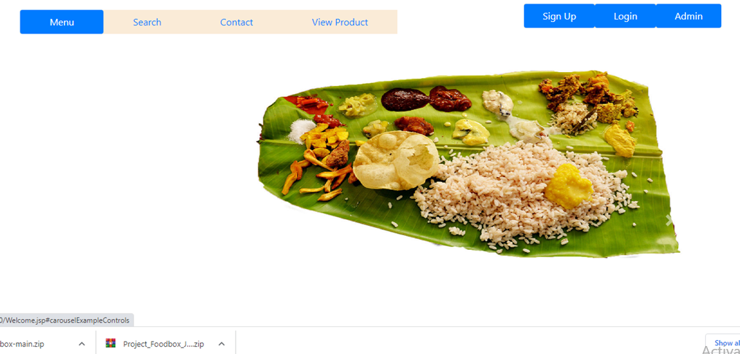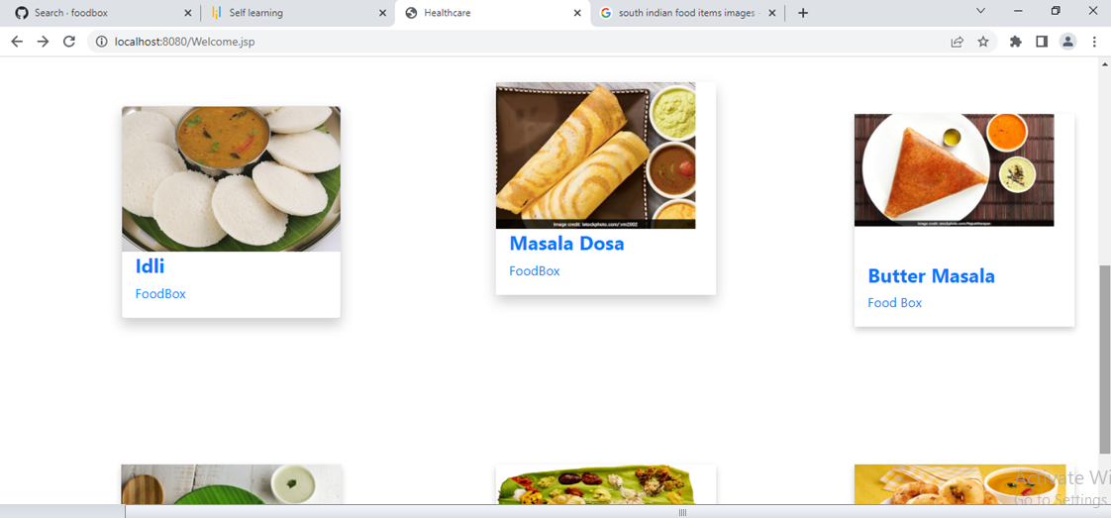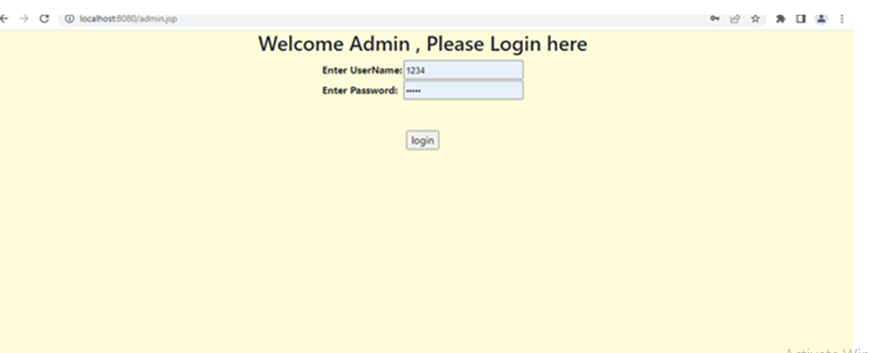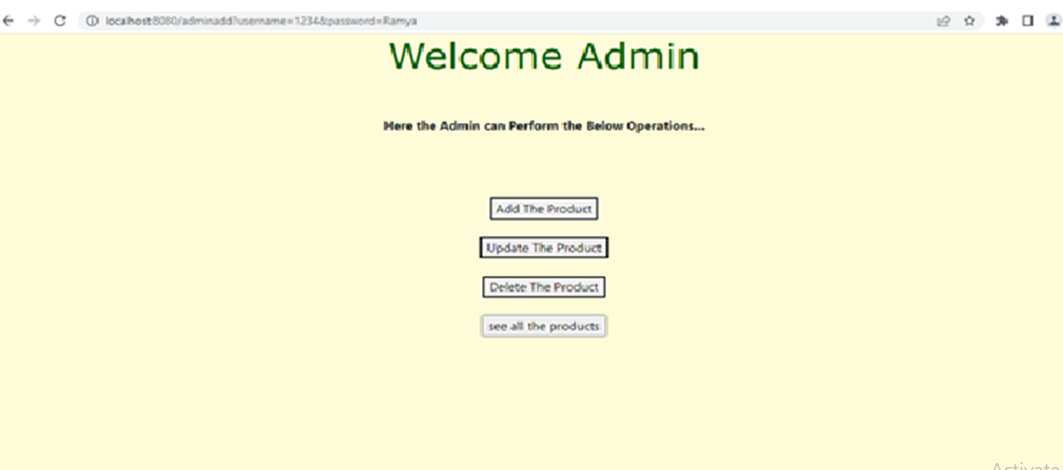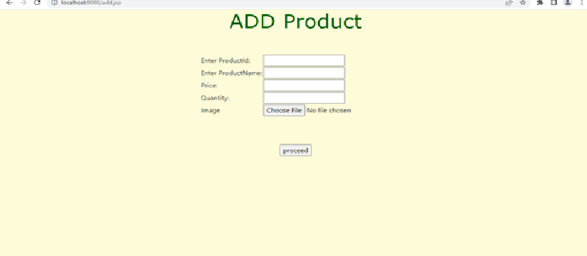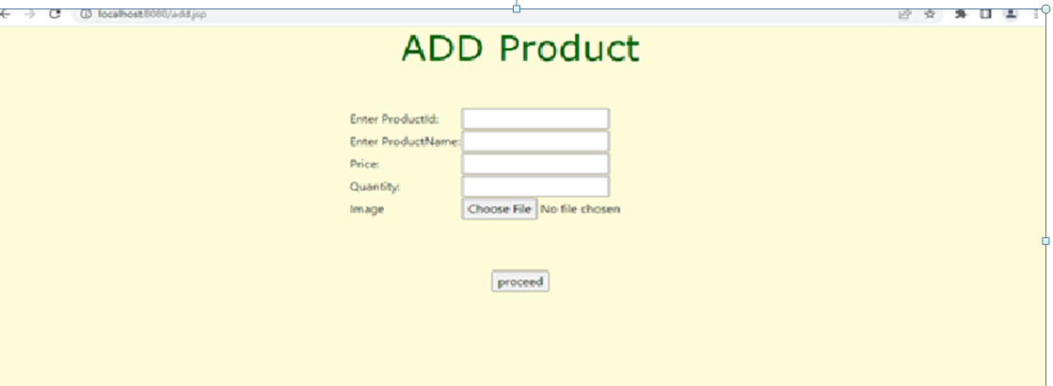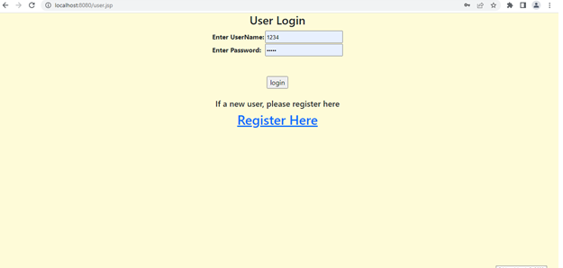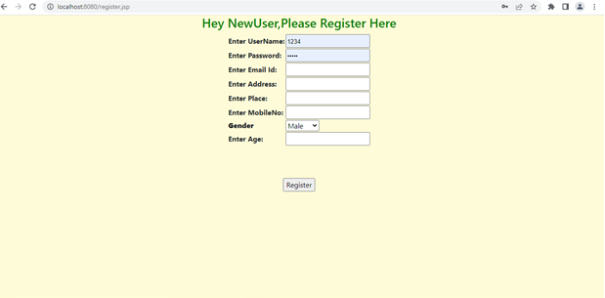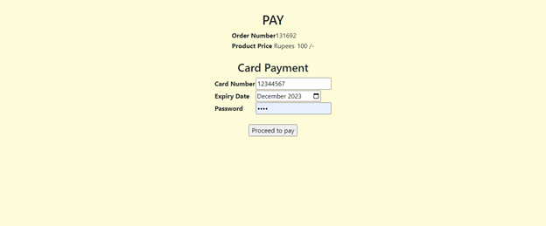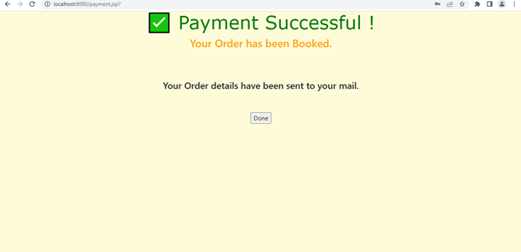

**Links to the GitHub repository to verify the project completion**

## **Pushing the code to GitHub repository**

* Open your command prompt and navigate to the folder where you have created your files.

**cd <** **D:\Foodbox\File>**

* Initialize repository using the following command:

**git init**

* Remote add the repository using the following command

**https://github.com/Mogilisanthi/Smplilearn-phase-7-foodbox-project.git**

* Add all the files to your git repository using the following command:

**git add .**

* Commit the changes using the following command:

**git commit . -m “Foodbox project”**

* Push the files to the folder you initially created using the following command:

**git push -u origin master**